Karson Burton-Reeder

Field Methods 271

Dr. Ryan Hill

October 18, 2023

Lab 11 Working with data

1. The sample size for the female butterflies was 10 individuals after SCC-1 was deleted and the size for males is 17 individuals.
2. The range of values for the females in the dataset is min 0.223 max 0.323, and the range for the males is min 0.148 and max is 0.242 for the body mass.
3. The range was odd at first because of the one SCC-1 .0223 but after it was deleted it was fine.
4. The outlier was the SCC-1 female at 0.0223
5. The average value for males is 0.188, and for females is 0.283.
6. The male female data does not overlap,

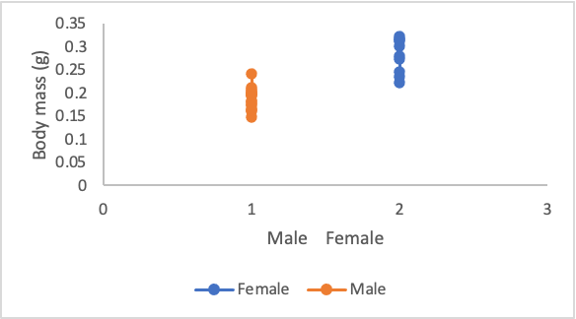

* 1. Figure 1: In this figure the body masses for males and female butterflies were graphed in grams and compared. The females have a higher body mass compared to the males.

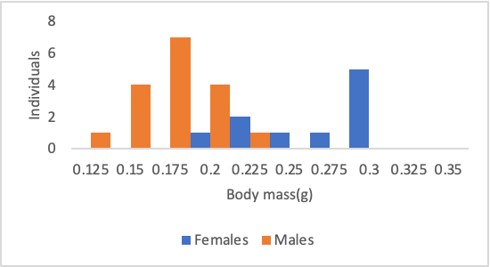

* 1. Figure 2: This figure the body masses from the individual males and females were graphed in grams. The variance is higher in the females, and they have a non normal distribution.

1. Our distribution for the females look to be a nice bell curve and is normally distributed but the males do not have a nice curve and have a non normal distribution
2. The variances are technically equal because they are both 0.001. But for females the variance is 0.001363 and males 0.00053.
3. The variance is not equal variances and are heteroscedastic
4. The female data have the higher variance compared to the males
5. Yes this makes sense from the data above because the males have larger and varied body masses. and the females have similar body masses.
6. In this study we will reject the null hypothesis because alpha is greater than the p value of 2.70946E-06. We can conclude that there is sexual dimorphism because there is a significant difference between the males and females when it comes to body mass.

R graphs

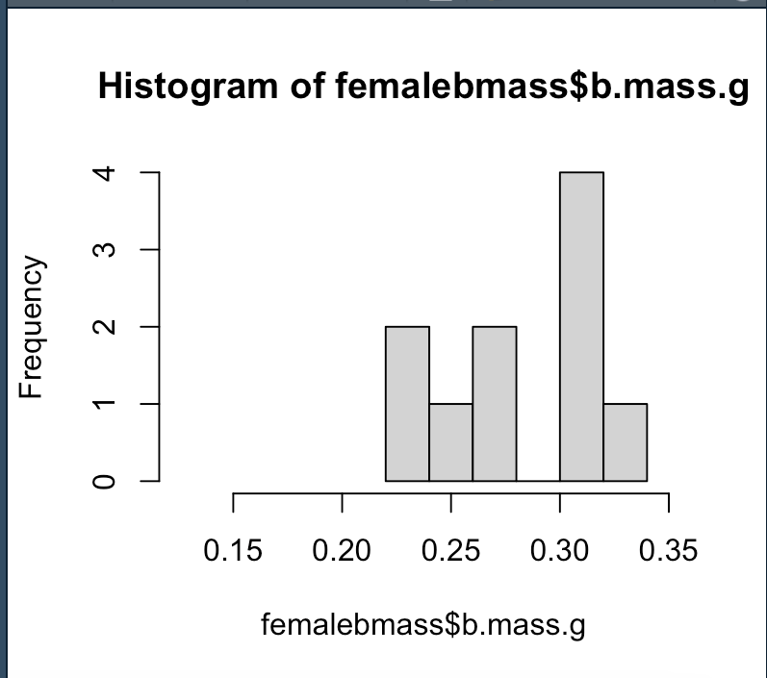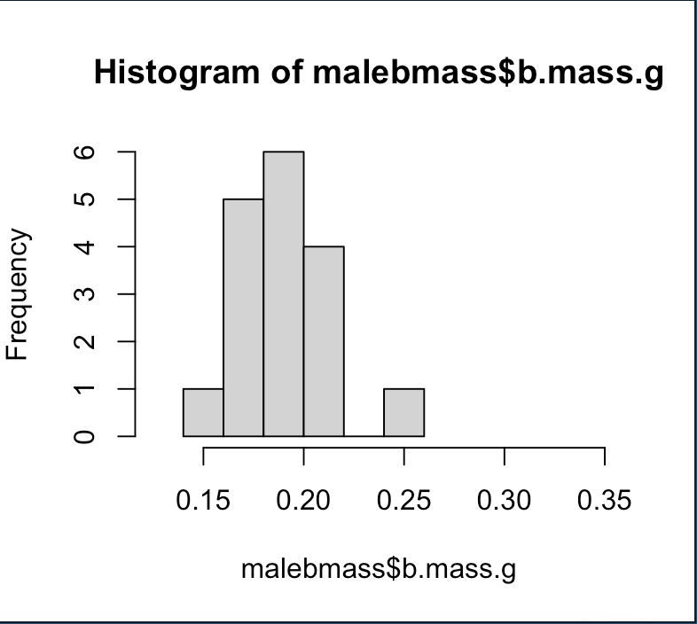

1. The males and females do overlap from .2-.25g of body mass.And the graphs show they do have significant differences.Also the histograms made in R and excel look identical and express the same significant overlapping and differences.
2. 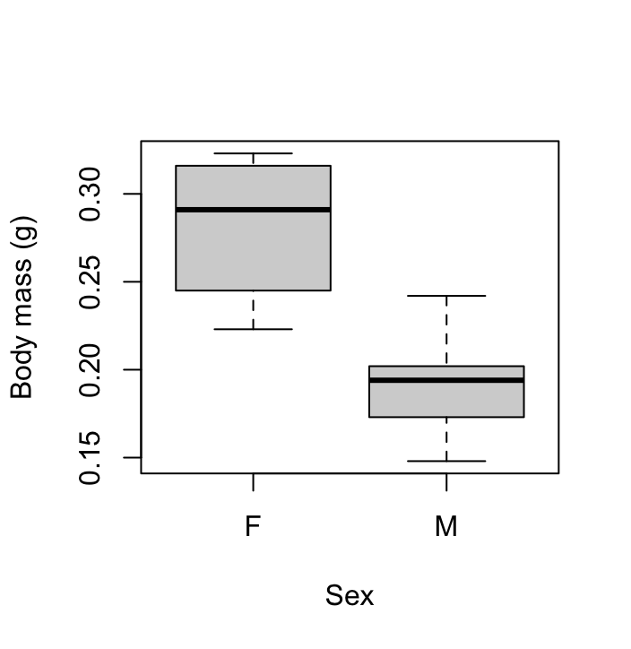This box plot shows the distribution of the body masses between the two sexes and still overlap at .2-.25g.
3. Using the R code for the male variance R calculated the variance to be 0.0005335588.And the females equaled 0.001362711.
4. The standard deviation for males was calculated to be 0.02309889. And females were 0.03691492.
5. data: massdata$b.mass.g by massdata$sex

t = 7.3015, df = 13.228, p-value = 5.419e-06

alternative hypothesis: true difference in means between group F and group M is not equal to 0

95 percent confidence interval:

0.06661723 0.12246512

sample estimates:

mean in group F mean in group M

0.2826000 0.1880588

1. We conclude based on this t-test that there is significant or true difference in the mean between the male and female body masses and we would reject the null because of the p-value being smaller than 5.419e-06.